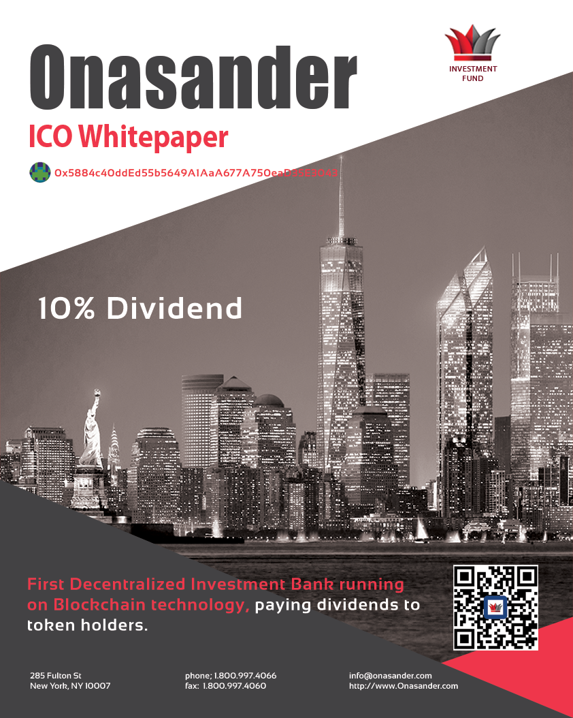

Table of Contents

1. Executive Summary 4

Highlights

Objectives

Mission Statement

Keys to Success

1. The ICO 5

The Whitepaper

Why Should You Even Read This?

What is ICO?

What is Onasander ICO?

Why Are We Doing It Now?

How Much Can Onasander ICO Make Me?

Where Will ICO Money Be Invested?

How Will ICO Reserves Be Stored?

ICO In United States of America

ICO Outcome

ICO Address

ICO Pricing and Schedule

ICO Timeline

1. The Investment Bank 11

Investment Fund

Asset Price Analysis Software – the Brain of Our Investment Fund

How Come Others Fail at Trading?

How Come We Will Succeed?

How to Convince You?

What Type of Trading Will Onasander Perform?

What Kind of Assets Will the Company Trade or Invest Into?

Will Onasander Have Clients?

Will the Fund be Only Online?

What Financial Products Will Be Offered?

What Financial Products Will Be Offered in The Future?

What Markets Will Onasander Trade On?

What Will Be Decentralized About This Investment Bank?

Onasander Timeline

1. The Offer 17

10% Dividend

How Will Company Gains Benefit Token Holders?

1. The Business 18

Who Will Manage Onasander?

Office Locations

Management Team

Positions Available After ICO

1. Technical Details 20

Cryptocurrencies

Ethereum Coin - ETH

Blockchain

Smart Contracts

Wallets

Exchange

How Will the Onasander Token Work?

How Will Onasander Tokens Be Minted?

Steps Required to Purchase Our Tokens

Purchase Tokens with Wire Transfer

Token Price Example

Onasander Smart Contract Specification

Final Token Distribution

1. Summary 25
2. Disclaimer and Terms of Use 26
3. Appendix 1 – Bearish Onasander Market Calls 28

Onasander Market Analysis 2018 – Current Chart and Analysis

Onasander Market Analysis 2008 – Chart and Past Trades

Onasander Market Analysis 2000 – Chart and Past Trades

1. Appendix 2 – Bullish Onasander Market Calls 31

Onasander Market Analysis 2018 – Current Chart and Analysis

Onasander Market Analysis 2009 – Chart and Past Trades

Onasander Market Analysis 2003 – Chart and Past Trades

1. Appendix 3 - Miscellaneous Documents 34

Start Up Summary

Start Up Expenses

Letter of Recommendation

Contact Information

# Executive Summary

This is my whitepaper for building the first decentralized investment bank crowdfunded using blockchain technology. The plan to open up an investment bank is to build an investment fund first. The fund, including our ICO tokens will be backed by tradable assets of this world. Simply put, by entire world economy. With time and trading the fund will be big enough to be converted into an investment bank.

## Highlights

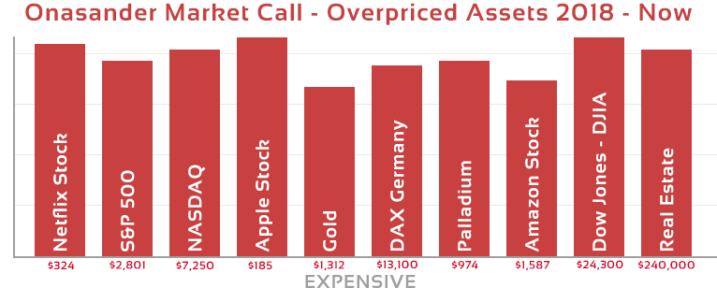The investment fund will pay **10%** **dividend** to all of our Onasander ONA token holders, as percentage of profits will be quarterly distributed to those who invested in our company. Onasander fund will turn regular profits, because of our experience, and because of its unique Asset Price Analysis Software called Onasander. Below is a chart from our Onasander trading application presenting most overpriced assets as of March 2018.

## Objectives

This photo was timestamped on the Bitcoin blockchain at: https://originstamp.org/u/60aa8167-f22e-d005-1acd-c5e4558b64a3

Our goal is to execute a very successful ICO, open up an investment fund, and take advantage of the upcoming stock recession, volatility, and price swings, all along benefitting our investors with dividends, and high token valuations. With time, the objective will be to manage wealth for our clients and grow the bank.

## Mission Statement

The climate for opening up an investment fund is perfect. We are living in interesting times. Free money flowing from central banks to in debt and bankrupt governments around the world created a major global bubble in many asset classes, where prices have reached an extreme. We are standing in front of an opportunity to open up a financial institution and make tremendous financial gains right from the start. The upcoming recession in the world financial markets will create price volatility, and opportunities for years to come. Using our unique Onasander trading software, we can foresee price movements and benefit from it.

## Keys to Success

The Asset Price Analysis Software is the key to our success. Our market tools developed over two decades have no competition in the financial world. They allow us to predict market moves, see upcoming recessions, identify bubbles, find major tops, spot asset price bottoms, and successfully trade in all market conditions.

# The ICO

The following few paragraphs will present you with the general concept of our ICO, its purpose, and what lead us to start the ICO in the first place. For all technical details please refer to our Technical Details section.

## The Whitepaper

The backbone of every ICO is its whitepaper. I read few of them, and I realized this white paper is not your ordinary whitepaper. Most whitepapers are professionally written. They sound intelligent on the outside, and carry a lot of high tech data, and powerful slogans. I’m sure some of them contain amazing ideas, but for the most part I don’t see them making money.

90% of those who will read this paper, or view my market trading calls, will probably disagree with me. My market calls will seem to be the exact opposite of what you hear on TV, read in the financial news, or hear from market gurus. That is what sets me apart and allows me to out trade everyone. I do not follow the general public, or other fund managers. Actually, most of the time I find myself on the other side of the trade. My trading revolves around my proven for decades Onasander software and its algorithms.

## Why Should You Even Read This?

You should read this because of my natural talent to make my dreams a reality. Let me show you what I have accomplished so far: I single handedly wrote this whitepaper without the use of college professors, I designed and programmed the website for Onasander.com. More, I learned a new language called Solidity and I wrote the ERC20 Smart Contract in that language. I audited the Smart Contract from the security perspective and launched it on the Ethereum network:   
  
<https://etherscan.io/token/0x5884c40dded55b5649a1aaa677a750ead35e3043>

On top of all this, I am my own attorney and legal advisor who created the legal structure for the company and registered the firm. Plus, I will be the person responsible for the Regulation A+ Tire 2 application submission. In addition, I prepared the marketing campaign for Onasander I will be the one executing it. Not to mention I invented the Onasander business and its algorithms. That is a lot of talent and a lot of success to ignore. Not to mention I already saved up about $500,000, as that’s how much it would cost to produce what I have developed myself. I am practical, skilled, efficient, creative, and sophisticated when it comes to accomplishing tasks. Onasander Investment Bank will be no different.

## What is ICO?

The ICO acronym stands for Initial Coin Offering, a mock-up of Initial Public Offering. Nowadays, any startup can issue its own currency, usually called tokens or coins, using blockchain technology. These tokens may be bought, sold, or exchanged for another cryptocurrency, such as Bitcoin, Ethereum, or for FIAT (read: normal) currencies.

The main goals for the issuer of the tokens or coins is to fund their project development, marketing, and help increase demand, which will then increase the value of the tokens. The final goal of the individuals who purchase tokens is to use them to exchange/buy/sell individual goods and items or do what most people do and wait until their price has skyrocketed and then sell them for profits.

## What is Onasander ICO?

It is the first decentralized investment bank ICO that we are planning to make legal in United States of America. The plan is to collect funds through crowdfunding. Next, we will open up an investment fund. The fund will trade and invest the ICO money using our Asset Price Analysis Software, until we are ready to turn the fund into an investment bank.

Our ICO will have three PRE ICO-phases and one final ICO phase. The token price in the initial PRE-ICO will be the cheapest and it will increase in value in the later phases. We reserve the right to adjust PRE ICO and ICO dates, but we guarantee to be completed with the ICO by February 2019. Please refer to the ICO Pricing and Schedule section for more details. Technical ICO specification is defied in the Technical Details section.

## Why Are We Doing It Now?

The timing of both cryptocurrency innovation, and the upcoming recession created a perfect environment for opening up an investment fund. Crypto currencies and its new technologies allow for capital to form very fast on global basis. This formation of capital is very positive for economic development. It opens up opportunities that were not available before. This makes it possible to create a successful investment fund ICO and build a financial enterprise on that foundation.

#### The Upcoming Economic Downturn

The upcoming recession has been in the works for quite a while. It’s actually overdue if you ask me. That is one of the most important reasons why I’m pushing for the project now. Great financial opportunities are on the horizon.

#### Current Market Analysis from Onasander Trading Software

Below I present you with a sample chart of our Onasander analysis for some of the most common asset prices. This data comes straight from the Asset Price Analysis Software. I’m including it here as a proof of our trading abilities. Our software has been sending “TOP” and “Overbought” signals on many asset classes, for some time now. In the future you will be able to come back to this chart and compare our predictions with real world outcome. This will allow you to validate if our Asset Price Analysis Software is right or wrong, and you will be able to see the reasons for our success. This chart prediction will bring in many clients and investors.  
  
Please note items in the Cheap column in the chart below are not really BUY Calls. These are some of the cheapest assets, but we do not recommend to buy them as there will be better deals. These four CHEAP items are listed as examples only.

#### 

This photo was timestamped on the Bitcoin blockchain at: https://originstamp.org/u/10ff810d-3182-187e-2140-a2fda51a466e

#### How Can We Profit from the Chart Above?

Depending on the timing of events going forward, we will either short, or just sell the EXPENSIVE asset classes and purchase asset classes from the CHEAP column. Assets that were leading the market in the bubble always correct the most, and those that were not performing lead the next bull market. In this case we can make money both ways, by shorting the expensive assets, and profits from those “shorts” will be used to purchase cheap assets and repurchase those shorted assets if they overshoot on the downside.

#### How to Take Advantage of The Recession?

Onasander is hoping to build the company quickly enough before the downturn starts, so we can take advantage of the upcoming price drops and enjoy a nice start to our project. Because of Onasander ICO we will be able to make big financial gains when the overpriced assets reverse. Many of the overpriced assets can be “shorted”. More, some of these assets will become “oversold” during the correction period. It means they will become super cheap and will be available for purchase as “deals” that will reverse upwards creating quick gains. We will be able to take advantage of that as well.

## How Much Can Onasander ICO Make Me?

I can make projections, but they will not be genuine. There is no way to precisely calculate our future success. It could very easily become the biggest world investment fund. The gains are unlimited here. Long term approach should provide the highest benefits. My vision is that we will be worth about 500% more after the first 24 months of trading. One or two years is enough to prove our investors we can make money using our software, especially if we manage to execute our ICO before the recession.

The first phase of PRE-ICO will be the cheapest. Those that purchase our Onasander tokens in the first phase will enjoy the biggest percentage gains. Every ICO phase after that will probably go up in value.

## Where Will ICO Money Be Invested?

ICO money will be traded in the most optimal and liquid assets our software indicates. That could include: stocks, some of the commodities, currency markets, and if opportunities arise we would trade in the crypto market as well.

## How Will ICO Reserves Be Stored?

ICO reserves will be stored globally across basket of FIAT currencies, crypto currencies, and some commodities. The exact proportions of the split among these asset classes will change from time to time and will stay a secret of the company. The reserves will be banked globally in order to remove state risk.

## ICO In United States of America

I strongly believe any ICO company omitting United States is not serious at building anything long term. We want to be fully USA ICO compliant. This will allow regular citizens of United States to purchase our tokens. **As of right now, accredited investors of United States are allowed to buy into our ICO**. The problem is related to ordinary citizens only. We do not want to leave them behind, as they are a big share of the market.  
  
The plan to be United States of America ICO legal is the following: The ICO sales will be divided into four phases. Three PRE ICOs and one final ICO phase. Each phase will be sold at a specific time. The first phase will be for non-United States investors. Only accredited investors from United States can buy into our first phase.

Once the first phase of the ICO is completed, we will have money in order to hire resources who will help us become Regulation A+ Tire 2 compliant in United States. Once USA compliant, we will include United States investors in the other three phases. Since Regulation A+ Tire 2 has a MAX CAP of $50,000,000 per year, we will have a MAX CAP of $50,000,000 as well.

In case we **cannot** obtain USA compliance, we will sell the last three phases of ICO tokens to the same type of investors as in the first phase.

## ICO Outcome

This ICO will not fail, because we know our trading abilities. We plan on a broad reach to investors in PRE ICO. Moreover, Onasander will inject private capital into the project as well. However, in case we do not manage to hit our full ICO targets due to market conditions, we will start small and multiply the holdings. The price of the token on the exchange will be proportional to the number of tokens sold. Less tokens sold equals bigger initial price of the token at the exchange. Dividend percentage per token sold will not change upon ICO outcome, as the dividend percentage will be fixed. This lowers the risk for all of us.

## ICO Address

Onasander ICO address: *0x5884c40ddEd55b5649A1AaA677A750eaD35E3043*

## ICO Pricing and Schedule

Onasander ICO will adhere to the following pricing and schedule:

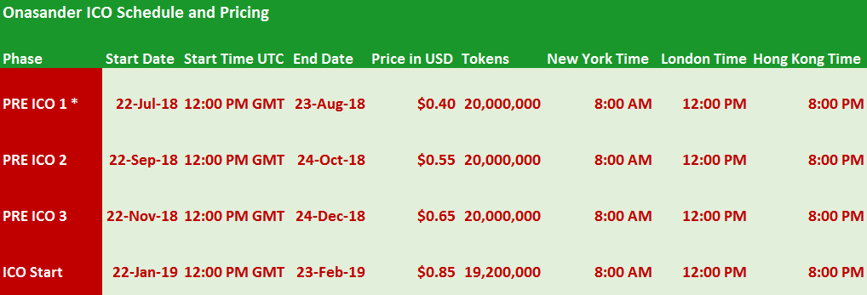

* The first phase of the PRE-ICO is for non-United States investors only.

ICO timeline dates and prices are dynamic, we reserve the right to change both parameters in case we need to. Please always make sure to check on our website for the latest updates.

## ICO Timeline

Onasander ICO could last until the end of February 2019. The monetary funding target is $50,000,000. The company will start trading and investing right after the end of the ICO. Splitting the ICO into PRE-ICO and ICO phases will accomplish few goals:

#### Reasons for ICO Division into Phases

* Money from PRE-ICO will be used for marketing and advertising for the later stages of the ICO.
* Onasander will have funds to complete the SEC Regulation A+ application process.
* Expending the ICO length will provide a greater chance to time and try to catch a crypto bull market, which would give us a shot at completing our full goal.
* Multiple phases of the ICO could drive the price of our tokens much higher over the 7-month period, allowing us to sell less tokens in order to reach the $50 million target. In case of Onasander ICO overwhelming success, in the ICO 7-month period, there could be “left over” tokens at the end of the ICO, due to fixed $50,000,000 cap, and higher token valuations every ICO phase. In other words, we may not need to sell all of our tokens in order to reach our money target. In that case, the left-over tokens after the 7-month period could be retired from circulation forever. In that scenario our Maximum Supply and Maximum Tokens Minted would be smaller than estimated in this document, driving the price even higher.

#### Onasander ICO Timeline Chart

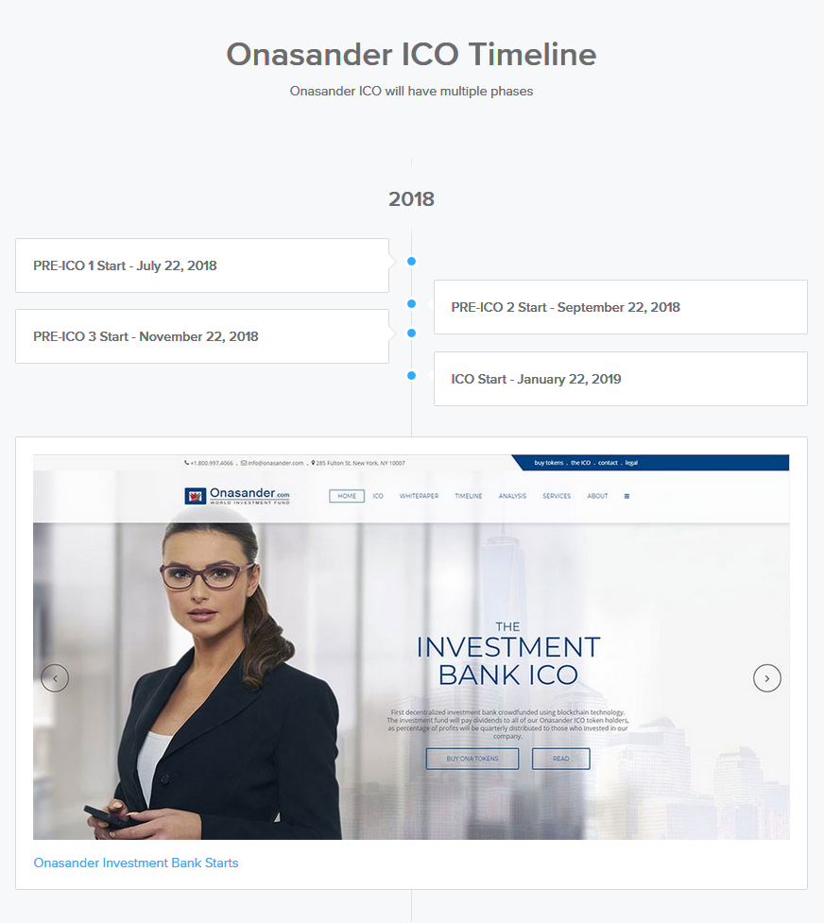

Each ICO phase will last for 33 days.

# The Investment Bank

There are only handful of investment banks in the world. Opening up an investment bank is not an easy process. Onasander strategy is to open up the bank in multiple steps. First, the goal is to execute a successful ICO. Then, using the ICO money, setup an investment fund and make it similar to a hedge fund. With time, growth, and experience, the plan is to turn the fund into an investment bank.

## Investment Fund

The cornerstone of our fund, and future bank will be our Asset Price Analysis Software. The growth of the institution will be based on our trading software. This trading software is our unique way of analyzing asset prices and forecasting deals.

## Asset Price Analysis Software – the Brain of Our Investment Fund

The name of our Asset Price Analysis Software is called Onasander, hence the name for the investment bank. The software itself is over 15 years old and has been forward tested since the beginning. It has been backwards tested for about 300 years on some asset classes.

#### How Onasander Works?

Our trading software collects prices of all the assets we are tracking. Based on those collected prices, it calculates if the asset is overbought or oversold. It analyzes those prices and creates investment plans for the most optimal gains. This is a dynamic process. As time goes on, the most optimal investment plan changes since prices of assets change. Trading team monitors the Onasander market calls and adjusts the portfolios, and trading positions so that they are aligned with the most optimal plan.

Onasander market calls provide us with the exact price for the trade entry and exit, along with precise timing. Knowing correctly what to buy, at what price, and when, is our most valuable, and unique part of the company. Our software can also predict trade entry points into the future for decades. Knowing when and what will be a price of assets in the future helps us to position our investments accordingly, so that not only we make money currently, we will also be ready for future trades.

## How Come Others Fail at Trading?

Almost all, if not all investors I came across in my life showed common flaws when it comes to investing. They were either emotionally attached to their bets, or they simply built their funds using people’s money, without any kind of understanding of asset prices. This includes famous fund managers, investment banks, and other famous people you see in the financial news. In other words, emotions, lack of patience, and lack of skillset makes people lose money in trading.

Knowing the history of investing I can confidently say most money managers fail under unfavorable market conditions, and almost all of them are well known and respected during a bull market. It is very easy to be a star when you use people’s funds and in a bull market. Using your own money, in all types of market conditions shows who can manage wealth. Another category of investors who fail on consistent basis is so called permabear and permabull investors, who have a very inflexible, and narrow market view. They miss a lot of market action by not being able to adjust.

What are some of the indicators that show people are always wrong when it comes to the price of assets? The most common is the price itself. It swings between extremes. That means people are trading with emotions. What are two strongest emotions in a human? Greed and Fear. The greed of human nature pushes the prices of assets higher, and the fear collapses the prices. Why is the collapse in prices always faster than the run up to the bubble? Because fear is the stronger emotion.

There is no exception to who fails in the financial world. I have seen the biggest names in finance fail over the years. Those failed institutions simply had no patience, and the financial market is a tool where money flows from inpatient to patient.

## How Come We Will Succeed?

We will succeed because of Onasander trading algorithms. I made money on almost all of my trades for the past 18 years. That is a long record. I lived through three major recessions, where I made the most money. All my trading knowledge and success was poured into Onsander software. Using my trading software, investments become relatively easy.

Knowing that I developed Onasander, some of you could be asking, so what’s so special about my trading that made Onasander successful? Below is my answer:

The nature of a price has many characteristics. As noted above the price is governed by two strongest emotions in a human body. It is those two exact emotions that create what I call price extremes. It is nothing more than price top and price bottom of a given asset in a specific time. The price of an asset swings from one extreme to the other, but at the end of the day, it never goes to the “Moon”, and it almost never goes to “zero” (it could go to zero on a specific stock or single item, but rarely as a whole).

The most interesting fact, and simplest at the same time is that price itself is a living organism, just like everything else in this world. It wants to be “normal”. It does not want to stay in one extreme or the other. As a matter of fact, price stays only for a brief time at one of the extremes. Most of its time the price spends gravitating towards some kind of an average, or balance.   
  
Price is similar to a human being. People can become super emotionally happy, or super sad, but it does not last long. Most of our time we spend feeling about normal. This price phenomena caught my attention in my early days of my career. With time I was able to realize all prices are on some kind of a path to “normalization”. It is the swings in one direction or the other that are the exceptions. Those exceptions happen on all time intervals. My success came when I was able to time each exception, calculate its boundaries, overlay the intervals, and quantify where on the path to normalization the price is at any given moment.

Onasander asset price analysis software has the ability to pin point and calculate major price extremes in both directions. It is not perfect, but it does not need to be. It is good enough to make money. Another major plus for us is the patience and lack of emotions Onsander trading algorithms provide. From experience we know there will be deals in the future. There always are. Therefore, we never chase prices. Nothing is more rewarding then having assets fall into our hands at our set prices. Our trading is based on one thing: buying at the right price at the right time. That is our biggest advantages over others. That’s where the success will come from.

## How to Convince You?

Our future price predictions will speak for themselves. Over time you will realize our market calls are correct, and the company will make money. Below is our current (March 2018) market call chart. This chart will pave the way for the investment bank.



This photo was timestamped on the Bitcoin blockchain at: https://originstamp.org/u/60aa8167-f22e-d005-1acd-c5e4558b64a3

Please visit the Appendix of this whitepaper to check out our broader market view and get familiar with our trading calls. All future predicting charts were timestamped on the Bitcoin blockchain for authenticity. No one will be able to say we created these charts after the prices have corrected.

## What Type of Trading Will Onasander Perform?

All trades will be longer term, value investment type of trades. Some trades will span days, or months, depending on asset class. In some cases, the investments can easily last for years, as that’s how long some bull or bear markets last.

We are not interested in high frequency trading, or any kind of computer driven trades. Sophisticated trading infrastructure, an army of mathematicians, or an army of traders. It is absolutely not part of what we are all about. Trading should be simply. When you make a correct market call, it outperforms most sophisticated algorithms and computers, and renders them irrelevant.

## What Kind of Assets Will the Company Trade or Invest Into?

I strongly believe there is money to be made in any asset as long as you purchase it at the correct price and time. However, we need to concentrate on assets that will provide optimal percentage gains and liquidity. Portion of our funds will be allocated to less known assets as we will go after deals no one else is focusing on. We will mostly concentrate our trading on the following asset classes:

#### Common Trading Asset Classes

* Global Stocks
* Commodities
* Currencies – (limited)
* Futures
* Bullion
* Energy
* Crypto Currencies
* Strategic Real Estate

## Will Onasander Have Clients?

Onasander will be a full-blown investment fund that will acquire retail, and institutional clients. We would be proud to manage other’s institution funds, wealth, and reserves. Down the line we would be interested in bringing municipality and state clients onboard. The company will also put strong emphasis on ordinary citizens with small accounts wanting to invest. All crypto currency clients will be welcomed as we will carry crypto currency investment products.

## Will the Fund be Only Online?

The company will trade using ICO money at first. That part will be all online. Once we mature as a company (within 24 months) and build our physical infrastructure, we will open up to non-online clients. With offices around the world, we will take onboard wealth of varies people and institutions. That part of business development will be done at physical locations.

## What Financial Products Will Be Offered?

The physical locations of our business will offer many financial products for our clients. This will take time as we will require office locations and financial team to develop relationships with clients. Some of the most common financial products are listed below.

#### Products Offered:

* Global Stock Purchases
* Commodity Purchases
* Crypto Currency Purchases
* Wealth Management

## What Financial Products Will Be Offered in The Future?

In the future, our fully-grown investment bank will offer many financial products covering interests of a broad range of clients. The list is not fixed and servers more as a sample, as we will always adjust to market conditions and client needs.

#### Future Financial Products:

* Global Stock Purchases
* Commodity Purchases
* Crypto Currency Purchases
* Wealth Management
* Investment Banking
* Capital Markets
* Investment Management
* Municipal Finance
* Commodity Portfolios
* Crypto Currency Portfolios
* Credit Derivative Products
* Onasander ETFs
* Mini Funds for Retail Investors
* Structured Derivative Products
* World Wide Web Properties (websites and domains)
* Crypto ETFs
* REITS

## What Markets Will Onasander Trade On?

Onasander will have a master allocation plan across assets and across markets. Most trading will happen in United States, but we plan to purchase stocks in China, Singapore, Europe, Russia, Japan, Brazil, and other emerging markets. Real Estate would be purchased locally for now, unless major deals present themselves globally.

## What Will Be Decentralized About This Investment Bank?

This bank will be registered as a normal investment fund with office locations and clients. The decentralized parts will include:

#### Decentralized:

* Buying our Financial Products will be done through Smart Contracts
* Investing in our bank will be cryptocurrency token based
* Most investment processes will be decentralized on a blockchain
* Each client of the bank will be a “node” on a blockchain network
* Dividend distribution will be completed through Smart Contracts
* Crowd Sale itself will run on decentralized Smart Contract
* In the future branches of our bank could become separate blockchain Master Nodes
* Future company voting system could run on Smart Contracts

## Onasander Timeline

* Hire Onasander ICO Team – **completed**
* Write the Whitepaper – **completed**
* Onasander Website – **completed**
* Develop Onasander Smart Contracts – **completed**
* Register Legal Entities for the company – May 2018
* Prepare Marketing Plan – June 2018
* Reach to Investors – June 2018
* **PRE ICO 1 / Pre-Sale** – July 2018
* Apply for SEC Regulation A+ compliance in USA – July 2019
* **PRE ICO 2 / Pre-Sale** – September 2018
* **PRE ICO 3 / Pre-Sale** – November 2018
* **ICO Sale** – January 2019
* Allocate ICO Funds – February 2019
* Get Listed on Crypto Exchanges – February 2019
* Lease Office Space – February 2019
* Start the Investment Fund – February 2019
* Purchase and Deploy Company Management Software – February 2019
* Establish Company Departments – February 2019
* Develop Company Policies - February 2019
* Hire Team Members – March 2019
* Open Up Trading Accounts in Different Markets and Countries – March 2019
* Develop Dividend Distribution Software for Token Holders – April 2019
* Develop Company Software for Asset Management – May 2019
* Develop Onasander Crypto Exchange – June 2019
* Hire Financial Advisors for Wealth Management Departments – November 2019
* Expend Wealth Management Line of Business – March 2020
* Create Onasander Financial Products – Q4 2020
* Offer Onasander Products to Clients – Q1 2021
* Hire Investment Bank Experts – September 2021
* Create Investment Bank Conversion Strategy – January 2022
* Prepare the Company for an Investment Bank Conversion – May 2022
* Expend all Departments to Cover Most Common Lines of Business – September 2022
* Turn Investment Fund into Investment Bank – June 2024
* IPO of the Investment Bank – June 2028

# The Offer

Our offer is simple. We use crowd funding to open up an investment fund backed by world assets. We trade those assets, and profits from the trading go back into the value of the company, value of the token, and back to the original investors as dividends of 10%. With time we turn the fund into an investment bank

## 10% Dividend

Onasander will pay dividends to our token holders. The value of the dividend is 10%. It will be paid every quarter with the following rules:

#### Dividend Rules:

* The 10% payment is based on Onasander quarterly profits.
* Token holders must own tokens at the time of dividend payment.
* Dividends are paid only for quarters in which Onasander made profits.
* Onasander tokens must be owned by the token holder during the quarter for which the dividend is being paid.
* In case our investor holds different token amounts during the given quarter, the smaller amount will be used to calculate the dividend payment. This includes the number of tokens owned on the dividend payment day (which will fall outside of a given quarter).
* For investors not being vested (holding tokens) throughout the full quarter, the dividend will be prorated for the amount of days it was held during the quarter.

## How Will Company Gains Benefit Token Holders?

Only limited initial investors will end up with our Onasander tokens. Everyone else will be a client of our company. The company will make revenue from trading, investments, and from client fees. Our revenue will fuel the price of the token.

#### Ways Investors Will Make Money with Us

* Dividends will be paid to token holders. Every quarter, percentage (10%) of net revenue from trading will be divided and distributed among all token holders.
* Higher value of the company will be reflected in higher token price on the exchanges.
* As successful trades by Onasander become publicly known, and the company starts to have consistent revenue, people will jump to buy our tokens on the open market, driving the price much higher.
* Once we establish an investment fund, and later on an investment bank, the profits from our clients will also become part of the dividends that will be distributed to token holders.
* As the wealth of the world grows, our token supply will stay fixed. This deflationary nature of the token will automatically grow its price.

# The Business

Our investment fund will start as an LLC company registered in the state of Delaware, United States of America unless we are not able to receive SEC Regulation A+ compliance in USA. It will continue as an LLC until we become an investment bank. At that point the fund will become a corporation, with a chance of being publicly traded.

Who Will Manage Onasander?  
The management of the company can be divided in three separate phases: Initial Phase, Established Phase, and Fully-Grown Investment Bank.

#### Initial Phase

In the initial phase I will start and manage the company. Using some of the ICO money I will build a small but super-efficient team that will be able to provide legal, financial, and IT services for Onasander. At first it will be about six people to get the fund of the ground. In this phase I will be the Founder and CEO of the company, which means I will run all day to day operations at the firm.

#### Established Phase

Once the company is fully established I will not run day to day operations. I will only be the Founder and trading brain behind the business. We will hire a CEO from the financial world, and a competent management team to help us implement the white paper timeline tasks. At that point I will serve as the advisor and visionary leader to the company.

#### Fully Grown Investment Bank

In this phase the bank will most likely be a publicly traded company, and it will behave like one, where shareholders and ONA token holders decide the faith of the bank.

## Office Locations

Onasander headquarters will be in Manhattan, New York USA. The fund will operate from there. Once successful and established, we will have an idea on how to build our office locations in Europe and Asia to accommodate our international clients. For Europe we are interested in the city of London, and for Asia we are aiming at Hong Kong.

Our decentralized investors will be provided with superior online platform to manage their portfolios and investments. This decentralized platform will eliminate need for office space and allow our investors to have hands on control of their trading. Smart Contracts will take care of investment audit, ownership, history, integrity, and management.

## Management Team

#### Andrzej Wegrzyn – Founder & CEO

I have 20 years of experience in trading and investing in varies assets. Over that time span I managed family related funds, and estates. I dedicated over a decade of my life to financial analysis, price behavior, trading software development, and anything related to price behavior while working at Morgan Stanley, and for my own company.

#### Anna Kretovitcz – Finance and Accounting

Anna comes from a corporate background. She ran companies in New York City and was a Chief Financial Officer at Michael Cohen Group (US Grants). She holds a CPA license and will be our go to person when it comes to running our accounting, taxation, and internal finance.

#### Robert Muer – IT Security and Development

Robert is freelancing for Onasander, but we are looking to hire him full time once ICO ends. Robert has an extensive background in IT security. His 15-year tenure in IT Security at various financial firms gave him tremendous experience in securing data, money, information, and info structure.

#### Adam Wagner – Developer & IT Lead

Adam is a developer who will be responsible for developing all reporting software for the company. His talents and leadership will be utilized where he will lead a team of developers to build dividend payment system for our ICO clients, back office applications, intranets, internal Onasander token exchange, and many more IT projects.

## Positions Available After ICO

Once we execute our ICO, we will be looking to fill few important positions to complete our 2018-2019 agenda. We setup many tasks on our project plan, therefor we will need to hire top talent for the following positions:

#### Positions:

* Business Developer
* Jr. Business Analyst
* Legal Advisor
* Marketing Strategist
* Smart Contract Developer
* Software Engineer
* Financial Advisor
* Jr. Financial Planner

# Technical Details

Onasander tokens are cryptocurrency ERC20 tokens based on Ethereum technology. Below you can get familiar with the technology and review how the ONA tokens will work, and how to obtain them in the ICO process.

## Cryptocurrencies

A digital currency in which encryption techniques are used to regulate the generation of units of currency and verify the transfer of funds, operating independently of a central bank. Bitcoin being more famous right along with Ethereum.

## Ethereum Coin - ETH

Ethereum is a cryptocurrency, and an open software platform based on blockchain technology that enables developers to build and deploy decentralized applications.

## Blockchain

A digital ledger in which transactions made in Bitcoin or another crypto currency are recorded chronologically and publicly.

## Smart Contracts

A smart contract is a computer protocol intended to digitally facilitate, verify, or enforce the negotiation or performance of a contract. Smart contracts allow the performance of credible transactions without third parties. These transactions are track able and irreversible.

## Wallets

A crypto currency wallet is a software program that stores private and public keys and interacts with various blockchain to enable users to send and receive digital currency and monitor their balance. If you want to use Bitcoin, Ethereum, or any other crypto currency, you will need to have one form of a digital wallet.

## Exchange

Website where you are able to buy and sell Onasander and other tokens.

## How Will the Onasander Token Work?

The Onasander token will work just like a Closed-End Fund. The number of tokens will be fixed. The tokens will be traded among investors on an exchange. Just like stocks, the token price will be determined according to the laws of supply and demand. It means it will often trade at a wide discount or premium to the net asset value backing the token.

Once listed on the exchange, you will be able to buy more, or sell your tokens. The Onasander token is deflationary by design as the supply is limited. As the company will grow the value of the token will grow with it.

## How Will Onasander Tokens Be Minted?

Onasander tokens will be minted with a symbol: ONA. Onasander tokens will be Ethereum based. Therefore, the Onsander ICO crowd sale will run on a decentralized Smart Contract that runs on the Ethereum Blockchain. It is secured with a 256-bit encryption which makes it secure and reliable. They are minted through an interaction with the ERC20 compliant Smart Contract. The contract runs on the decentralized chain. The contract is simply a code that runs on the network and mints new tokens whenever funds are sent into the contract.

These tokens are a digital representation tracking the funding of our ICO and crowd sale. They are divisible units and are designed to have eighteen decimal digits. The minimum buy amount which can be represented in the compliant wallets, as mentioned below, is 0.00000001 ONA. Simply put, Ethereum is sent into the contract using one of the following Ethereum Wallets:

#### Hardware Wallets

* Ledger Nano S
* Trezor
* KeepKey

#### Desktop Wallets

* Exodus
* Mist
* MetaMask
* Ethereum Wallet

#### Web Wallets

#### MyEtherWallet

#### Coinbase

#### Mobile Wallets

* Jaxx
* imToken
* CoinBase

#### Paper Wallets

* ETHAdress
* MyEtherWallet - they provide paper wallet option on their website

Please note the above-mentioned wallets change pretty often. Always research your best wallet options. In case the investor does not have a wallet, he can simply fund these wallets using FIAT currency (real money), and purchase Ethereum on an exchange. He then sends the Ethereum into the crowd sale Smart Contract address. It is very important not to send your Ethereum tokens straight from the exchange to our address. You need to send your Ethereum tokens from the exchange to your non-exchange Ethereum wallet first, and then from that wallet to our address.

#### Onasander ICO crowd funding address: 0x5884c40ddEd55b5649A1AaA677A750eaD35E3043

## Steps Required to Purchase Our Tokens

The first pre-ICO token sale will start on July 22, 2018. In order to be able to buy our first cheap tokens you need to be ready before July 22. You will need to have your wallet and ETH ready before the PRE-ICO date.

Most important step for the investors is to have their Ethereum ready. Follow the steps below in order to be ready on the first day of Onasander Token Sale.

#### 1. Create Your Ethereum Wallet

Please refer to the wallets section in this document to choose your favorite ETH Wallet.

#### 2. Purchase Your First Ethereum (ETH)

In order to purchase Onasander tokens, you will need ETH coins in your wallet. You can purchase Ethereum coins on one of these exchanges: Coinbase, Kraken, Bitfinex, Bittrex, or any other exchange. Some of the above-mentioned exchanges allow you to trade FIAT currency (dollars or euro) for Ethereum directly, while others only allow exchanging Bitcoin or another cryptocurrency to ETH. One super easy way to purchase ETH is Coinbase. Coinbase will exchange your money for ETH and send them to your wallet.

#### 3. Send Ethereum From an Exchange to Your Wallet

This is an important step. Most exchanges do not allow you to send ETH directly to ICO contract address. The ETH coins will go out, but they never arrive at the ICO address. It is very important to send your ETH coins from the exchange to your ETH wallet first.

#### 4. Send Ethereum From Your Wallet to Onasander ICO

The next step requires you to visit our website www.Onasander.com and obtain Onasander Contract Address or copy the address below. On our website you will see the following information:

Contract Address  
0x5884c40ddEd55b5649A1AaA677A750eaD35E3043  
check contract address on: <https://etherscan.io/token/0x5884c40ddEd55b5649A1AaA677A750eaD35E3043>  
Minimum Contribution: 0.1 ETH

The most important thing here is the contract address. It’s just another wallet like yours. Below is an example of a wallet sending ETH to our ICO Contract Address.  
 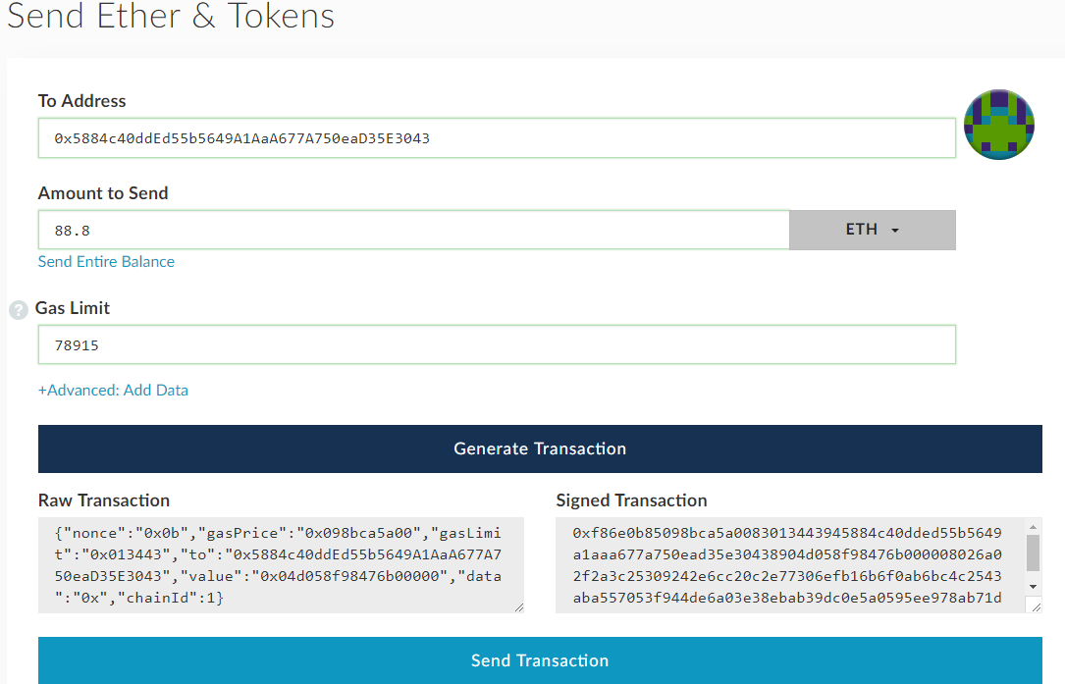

## Purchase Tokens with Wire Transfer

For investors who want to purchase our tokens with the wire transfer option, we invite you to visit our website <http://www.Onasander.com> and contact us directly.

## Token Price Example

When Ethereum is deposited into our Smart Contract address, the Onasander tokens are issued right away based on a mathematical equation. Based on the absolute minimum buy-in, in terms of Ethereum, the concept is the following:

#### Example for May 8, 2018

With the price of Ethereum of $700, and price of Onasander of $0.40, the investor receives 1750 Onasander tokens for 1ETH coin. Please note the price of ETH changes. The example below is based on ETH price of $700. Real prices will be different.

1 ETH = $700  
1 ONA = $0.40  
1 ETH = 1750 ONA  
1 ONA = 0.00058725 ETH

## Onasander Smart Contract Specification

Token Symbol: ONA  
Token Name: Onasander  
Token Type: Ethereum ERC20 token.  
Token Decimals: 18  
ERC20 Contract: 0x5884c40ddEd55b5649A1AaA677A750eaD35E3043  
Crowd sale Hard CAP of $50,000,000. Sale stops automatically at maximum value if under SEC regulations  
Refunds would be in Ethereum ETH.   
Max Tokens: 88,000,000 ONA  
Tokens for Sale: 79,200,000 ONA  
Minimum Buy In: 0.1 ETH  
Smart Contract: https://etherscan.io/address/0x5884c40dded55b5649a1aaa677a750ead35e3043  
  
The Maximum Available Supply will be 79,200,000 ONAs in case we sell all tokens (team reserve tokens are excluded as they will be off the market). All numbers above are based on maximum ICO sale. The price of the token on the exchange will be proportional to the number of tokens sold.  
  
In case of tremendous success after the initial PRE-ICO sale, the token price will go up for the next ICO phase, but the number of tokens sold could be less. Our target of $50 million is fixed. Therefore, the Available Supply of Onasander tokens could be much less in reality, due to price increase since higher price equals less tokens required to be sold. The “extra” tokens will be burned after the ICO. The Burn function was implemented in the Smart Contract.

## Final Token Distribution

The chart below represents how Onasander tokens will be distributed.

# Summary

In this whitepaper we showed you how we are going to build an investment bank using crypto currency based ICO. Opening up an investment bank will not be easy, that’s why we are going to accomplish our goal in steps. Onasander plan is to execute the ICO, open up the investment fund, and with time turn it into the first decentralized investment bank.

Those reading this whitepaper would probably agree on one thing: the world is changing. New technologies open up new opportunities. Crypto currencies give us options to form capital globally and accomplish what seemed impossible before. At Onasander, we believe the future is bright ahead for those that are able to adapt and embrace the changes.

We hope our ICO will be very successful, and our investments return lucrative dividends to the owners of Onasander tokens. Thanks to our unique Asset Price Analysis Software, we have a chance to build something great. Moreover, we believe this civilization stands in front of an amazing opportunity to develop a new money system for the world. Let our investment bank be part of it.

Thank you for reading until the end. Those of you that do not invest, we welcome you to follow our progress. To those that will invest in Onasander: Make no mistake, this ICO has a potential to be the biggest project build by crowdfunding. You will be part of something great and revolutionary. Your trust in us will be rewarded for years to come.

Welcome aboard. You will be the builders of tomorrow.

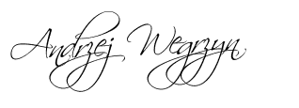

ANDRZEJ WEGRZYN  
March 21, 2018

# Disclaimer and Terms of Use

Taking part of an ICO involves risk. There is no guarantee that any coin or token will rise in value, or that the rise in value will be consistent over the years. We will try to be as transparent as possible. We do not accept any liability for any error or omission.

We do reserve the right to cancel the ICO and refund all the money. This could only happen in case of major unforeseeable event. In case of a refund all money would be refunded using ETHEREUM.

#### Market Opinions:

Any opinions, news, research, analysis, prices, or other information contained in this whitepaper is provided as general market commentary and does not constitute investment advice.

Another important thing: Onasander LLC, and any of its nominees, Onasander.com and its representatives, members, directors, partners, employees, agents, owners, contractors, or anyone related cannot give investment advice.   
  
Any of these people mentioned above, are never to be held liable by you for any direct, incidental, consequential, indirect, or punitive damages or losses arising out of your access to, or use of, the whitepaper and website.

#### Location

It is up to the discretion of each individual that is willing to invest in our ICO to make sure they don’t partake in an activity that may be illegal in their country of residence. Countries excluded from this ICO are: United States of America. Only accredited investors from USA are allowed to invest in the first phase of the ICO. The next ICO phase is reserved for regular USA investors upon Onasander becoming compliant with USA laws.

Please note that some jurisdictions may not allow the exclusion of implied warranties, so some of the above exclusions may not apply to you. Check your local laws for any restrictions or limitations regarding the exclusion of implied warranties.

This disclaimer and terms of use are governed by the laws of United Sates of America. If a dispute arises for any reason all parties agree, at the sole discretion of Onasander LLC, to first attempt to resolve same with the assistance of an arbitrator in the following location:

##### New York, New York, United States

We do our best to ensure the website is available 24 hours per day, but we cannot be held liable if for any reason the site is not available. Anytime you decide to click on any link to any site from our site, it doesn’t mean that we have checked these other sites. You must link at your own risk.

If you say or put up any information anywhere on our site or bulletin, you and you alone will be held responsible for any law you break by doing so. Bottom line: Don’t publish anything illegal on our site or try offending anybody with any unlawful, libelous, defamatory, obscene, scandalous, inflammatory, pornographic, nasty, or profane material.

#### Distribution:

This whitepaper and the information contained in the whitepaper are not intended for distribution or use by any person in any country where such distribution, or use would be contrary to local law or regulation.

You should not take part in the ICO if you reside in any country where the provision of such services or investments would be contrary to local law or regulation. It is the responsibility of the participants to obtain independent tax, or financial or legal advice should he, or she is uncertain, and to comply with any local law or regulation to which they are subject.

#### Extension

The legal Terms and Conditions plus the Privacy Policy from our website [www.Onasander.com](http://www.Onasander.com) applies to this whitepaper as well.

# Appendix 1 – Bearish Onasander Market Calls

The following charts represent some of the most overpriced markets in the last 18 years. You can view our current market analysis and past performances during bearish market calls.

## Onasander Market Analysis 2018 – Current Chart and Analysis

As of 2018, most of investments in this world, except for few commodities are overpriced. All of these asset prices will correct downwards in the near future for at least 50%. We have a major bubble in the financial sector, as well as in many other sectors. Most overpriced assets include: IT stocks, stock indices all over the world, Real Estate, selective commodities, collectible cars, gold, and palladium.



This photo was timestamped on the Bitcoin blockchain at: https://originstamp.org/u/60aa8167-f22e-d005-1acd-c5e4558b64a3

#### Stocks

Stocks and IT stocks in particular are leading the bull market. There is a basket of stocks which were favorites on Wall Street for almost a decade now. These stocks are in major bubble territory and will be leading the correction. Those include: Netflix, Apple, Amazon, Facebook, Google, Twitter, Adidas AG, and alike. These stocks were purchased blindly by retail investors, hedge fund managers, investment banks, and varies governments from all over the world. Cheap credit pushed these stocks to unsustainable levels.

#### Real Estate

Real Estate is also in trouble. Nobody realizes, but Real Estate prices reached 2008 bubble era levels again, and in some markets, Real Estate managed to surpass 2008 levels. Overpriced Real Estate markets will crash. Real Estate is location specific, and here is a list of overpriced markets that will correct: Vancouver, Toronto, New York, Los Angeles, Boston, San Jose, Tampa, Seattle, and others.

#### Commodities

Commodities are not trading with the broader market. Few commodities like Palladium are in a bubble. Gold is also expensive. It peaked in 2011 and is slowly correcting. Most commodities bottomed in 2016. Therefore, there is only a handful of commodities that can be shorted.

## Onasander Market Analysis 2008 – Chart and Past Trades

Charts below show a history of Onasander trades in 2008. Asset classes in the table below were overpriced. You can view how much the price has corrected, and how much one could make using Onasander in 2008.

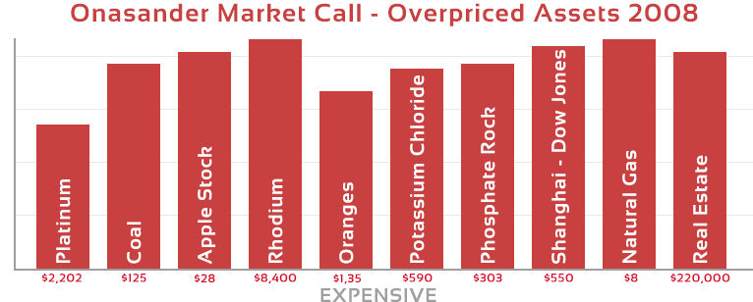

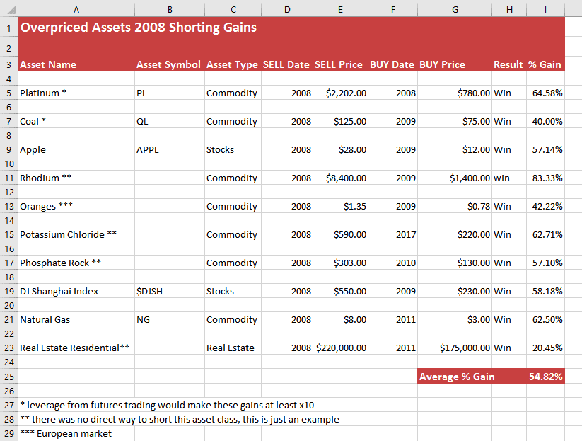

## Onasander Market Analysis 2000 – Chart and Past Trades

Charts below show a history of Onasander trades in 2000. Asset classes in the table below were overpriced. You can view how much the price has corrected, and how much one could make using Onasander.

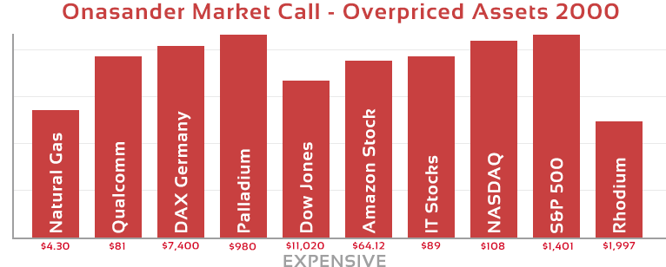

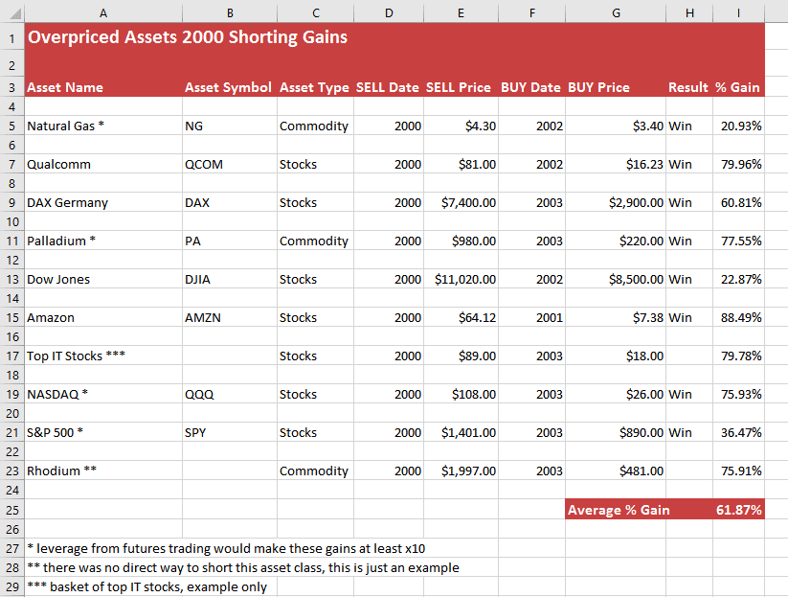

# Appendix 2 – Bullish Onasander Market Calls

The following charts represent some of the cheapest markets in the last 18 years. You can view our current market analysis and past performances during bullish market calls.

## Onasander Market Analysis 2018 – Current Chart and Analysis

As of March 2018, the world is in a major asset bubble. Therefore, there are very few asset classes that are in the BUY category. The below listed assets are some of the cheapest of them all, but because of the bubble I would expect some of these items to get even cheaper. Assets below are not recommended for purchase at these prices, this is an example only. They are cheap, but not the cheapest.

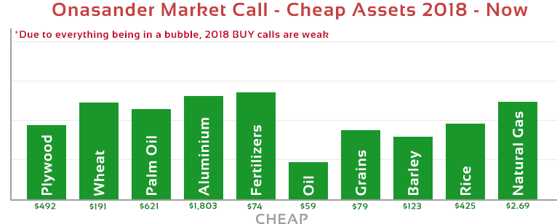

*This photo was timestamped on the Bitcoin blockchain at:* [*https://originstamp.org/u/4618f9f1-c283-a445-9ddb-9ea70d18e76d*](https://originstamp.org/u/4618f9f1-c283-a445-9ddb-9ea70d18e76d)

Quick look into the chart shows the cheapest assets of right now are all commodities. It is not without a reason. The world invested in information technology, and the financial sector more than in traditional economy, due to cheap credit flowing from the central banks, propping up stock markets. Looking at the above chart, any investor should be able to foresee the future. The financial sector will correct downwards, and the commodities sector will explode upwards.

The last time this exact scenario played out was in 1999-2000. Stock market and all financial assets were in a major bubble while commodities were at their cheapest ever. What followed after 2000 is exactly what will follow after 2018. Commodities started a bull run after 2000 and most of them peaked in 2008, while the financials collapsed in 2000 and entered a bear market.

In 2018 the correct course of action is sell your financial investments, and short them until they retrace at least 50%. Our asset price analysis software advises NOT to purchase anything until the correction, or until Onasander sends out a BUY signal on an asset.

In 2016, the world has seen few commodities reach a bottom. Investments such as Oil, Rhodium, Coal, Nickel, Aluminum, and others did bottom, and we do not expect them to be much cheaper than in 2016.

## Onasander Market Analysis 2009 – Chart and Past Trades

Charts below show a history of Onasander trades in 2009. Asset classes in the table below were cheap. You can view how much the price has gone up, and how much you could make using Onasander.

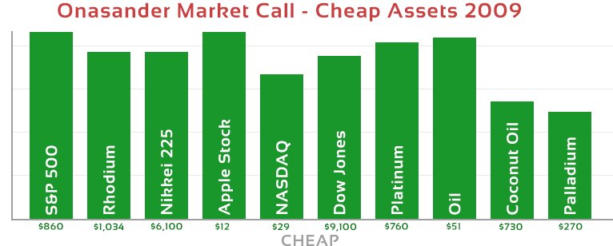

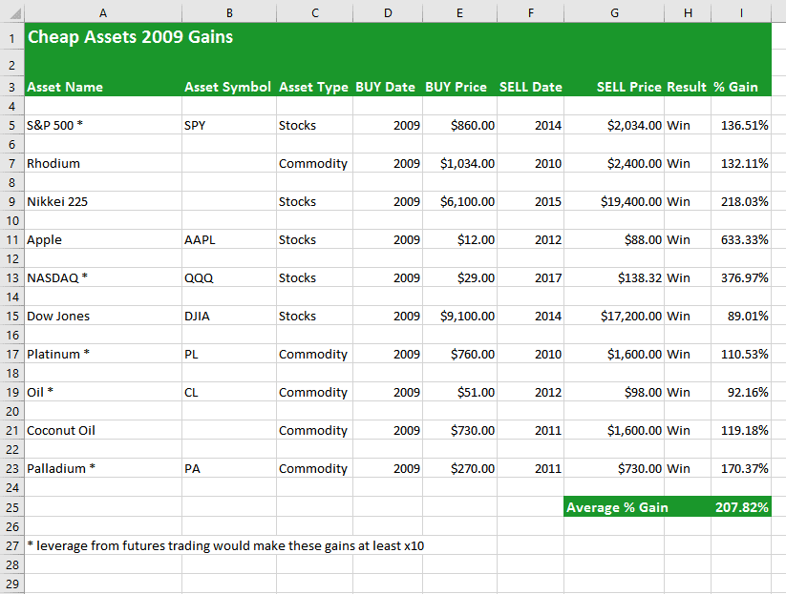

## Onasander Market Analysis 2003 – Chart and Past Trades

Charts below show a history of Onasander trades in 2003. Asset classes in the table below were cheap. You can view how much the price has gone up, and how much you could make using Onasander.

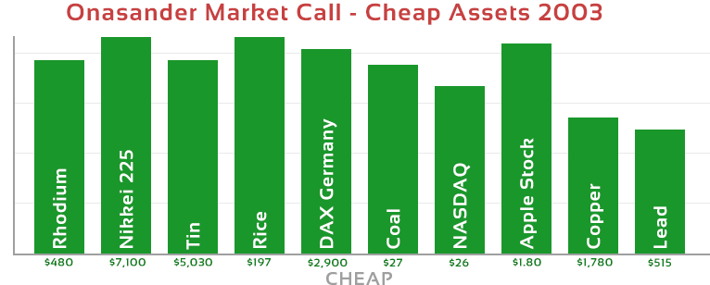

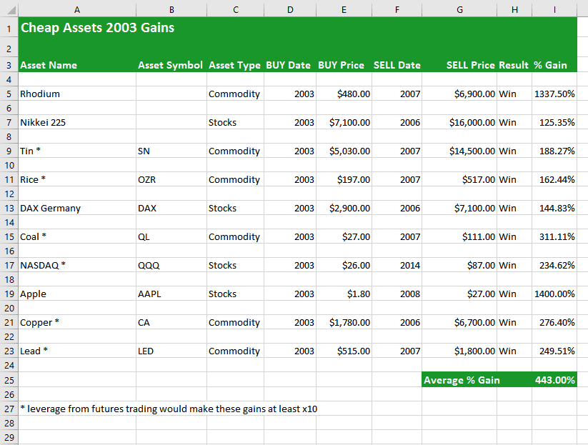

# Appendix 3 - Miscellaneous Documents

## Start Up Summary

Here is a summary of the key details concerning the startup of Onasander. The startup will have two phases. Pre ICO-phase, and Post ICO phase. Both phases deal with two separate realms of the project and require separate strategies.

#### PRE ICO-Start Up

This phase summarizes everything related to the ICO. We came up with a simple strategy that will guarantee us successful completion of the ICO. The plan is to use our own funds to pay for the ICO related expenses except for marketing and online advertising. That way we will be able to preserve investor funds during the ICO period and use some of PRE-ICO money for advertising only. Therefore, the Onasander ICO will have official PRE-ICO stages.

Moreover, money currently owned by Onasander will be used for the development of the ICO: Whitepaper, Smart Contracts, Smart Contract Audit, Onasander website, Onasander software, legal counsel, and related. The completion of the above-mentioned projects will cost around $193,700. This means Onasander will require money only for the most important part of the ICO, which is marketing.

Being able to run PRE-ICO and use some of its funds for marketing will provide us with tremendous advertising advantage. This advertising power will translate into the success of the ICO. The ICO success will in turn fuel the startup of the actual investment fund. Hitting our full $50,000,000 target will give us many trading options and allow us to invest in all upcoming opportunities.

#### POST ICO Start Up

In this phase the startup summary is related to all tasks related to the creation of the investment fund. Tasks related to this phase will include preparing office location, hiring investment fund team, setting up company departments, setting up company management, procedures, and operations.

Money for this phase will be used from the ICO. Initially, we plan on building an efficient team for the fund. The wealth management department in the first year of the fund will be very small, therefore, we will not need to hire a lot of personnel. Most of the business will include investing the ICO money and turning profits with that money alone. This will be enough to grow the fund balance sheet and develop the company for 2020, where we will offer our wealth management services to clients.

## Start Up Expenses

Startup expenses will be held to the minimum. The most expensive part about the ICO will be marketing and all types of advertising. Almost all employment expenses in the initial phase will be paid with ICO Team tokens, except for free-lancing employees who will need to be paid using our cash reserves.

Once the ICO ends, and the physical location opens up, we will have ongoing monthly expenses related to rent, employment, and whatever expenses there will be tied to running an office.

#### Expenses

|  |  |
| --- | --- |
| Incorporation Expenses | 8,200 |
| Deposits |  |
| Rent (Monthly) | 8,000 |
| Interior Modifications | 3,000 |
| Equipment/Machinery Required: |  |
| Office Equipment | 4,200 |
| Computers | 7,500 |
| Phone System | 3,600 |
| Other | 2,000 |
| Office Supplies | 2,400 |
| Insurance | 3,500 |
| Stationery/Business Cards | 1,200 |
| ICO Expenses |  |
| The Whitepaper | 7,000 |
| Smart Contract | 48,000 |
| Smart Contract Audit | 26,000 |
| Onasander website | 34,500 |
| ICO Marketing | 120,000 |
| Legal Fees | 26,600 |
| Angel Investor Advertising | 40,000 |
| Social Media Setup | 8,000 |
|  |  |
|  |  |
| Total Startup Expenses | $353,700 |

## Letter of Recommendation

Sebastian R. Schneider  
Bodis.com LLC  
228 Park Ave S #36792  
New York, NY 10003

February 2, 2018

To Whom It May Concern:  
  
This is my recommendation letter for Andrzej Wegrzyn. Me and my company Bodis.com have a long-standing connection with him. He was our domain portfolio and wealth manager for many years. Our funds are still under his management and we have been nothing but graceful for his outstanding service. Therefore, this letter gives us a great way to give back for his hard work for Bodis LLC.

Andrzej is more than qualified to manage financial wealth. He ended up managing Bodis asset portfolios by accident. Back in 2008 we were not looking for anyone to manage our assets or domain portfolios. It was Andrzej Wegrzyn who showed us future price trends for domain portfolios, and online advertising. In 2008 his asset analysis software was able to predict a correction in domain prices and internet traffic valuations. It was him who told us the prices will come down in the next 12 months and Bodis will be able to find deals in the overpriced market.   
  
I was not sure about the prediction due to a very severe recession but having cash reserves we started purchasing assets and following Andrzej’s advice. By the end of 2009 we ended up owning a multitude of assets which turned out to be deals of the decade. Ever since we followed Andrzej’s financial recommendations and were able to take advantage of his advice and market conditions.   
  
Knowing Andrzej’s unique view of the world financial affairs, trading, investing, and overall approach to money, I highly recommend him without any kind of reservation to be your wealth manager. His financial analysis is different, and his investing patience turns him into the best fund manager I have ever come across. He always seems to be two steps ahead, pointing to you what exactly will happen next in the world economy.

It is with much enthusiasm that me and my company fully recommend Andrzej Wegrzyn, who is a superior money manager, and we stand ready for any further information you may want to know about him.  
  
Sincerely,  
  
Signature  
  
Sebastian R. Schneider

March 24, 2018  
285 Fulton St   
New York, NY 10007

To:  
ICO Investors

**Dear Sir or Madame:**

I am applying to be your wealth manager and investment banker. For the last 18 years I have been a trader and investor managing wealth under the Onsander fund. I started the fund for family and friends, and that’s where I managed stocks, ETFs, internet properties, commodities, bullion metal, and Real Estate portfolios. Along the way I invented an asset price analysis algorithm which allowed me to be a successful trader in all market conditions.

As long as I remember my life dream was always to open up an investment bank and manage wealth for others. My goal aligns with your goal of making money. Driven by my long history of successful investments, and invention of crypto currencies motivated me to put my dreams into reality and make Onasander an official investment fund. Taking advantage of the upcoming global recession will be the ticket I need to become your money manager. I will out trade everyone and prove to you Onasander can be a very successful venture.

Thank you for reading my letter. For those who would like to speak more about my ideas I am easily available through <http://www.Onsander.com> contact information.  
  
Sincerely yours,



ANDRZEJ WEGRZYN  
FOUNDER & CEO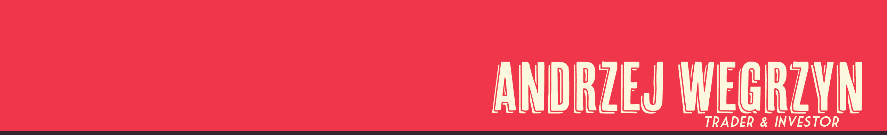

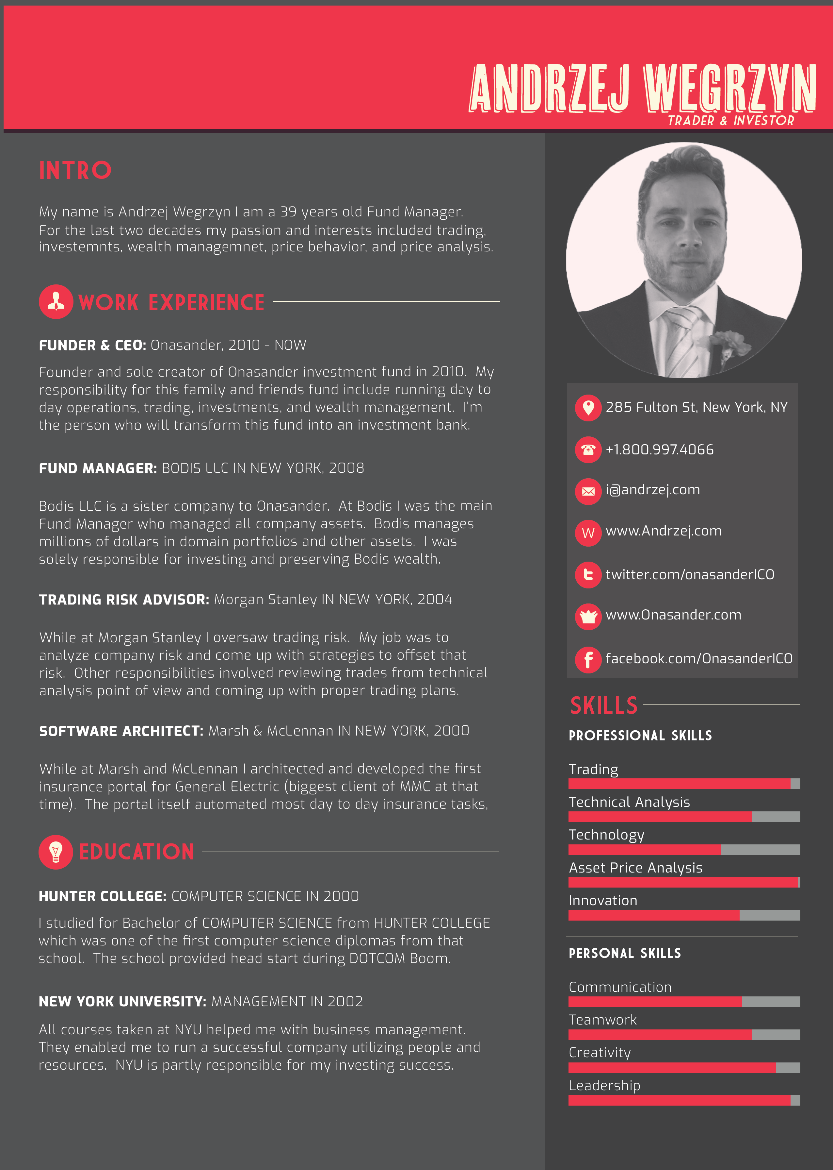

## Contact Information

[](https://twitter.com/OnasanderICO)Onasander  
285 Fulton St   
New York, NY 10007  
<http://www.Onasander.com>  
email: info@onasander.com  
phone: +1.800.997.4066  
  
 ANN Thread: <https://bitcointalk.org/index.php?topic=3948353.0>

[](https://www.facebook.com/onasander.ico.bank) Twitter: <https://twitter.com/OnasanderICO>

[](https://www.linkedin.com/in/onasander-ico-3862a7161/)Facebook: <https://www.facebook.com/OnasanderICO>

[](https://github.com/onasander) LinkedIn: <https://www.linkedin.com/in/onasander-ico-3862a7161/>

[](https://t.me/joinchat/G52Z0g2M0gnvX6L-92UZvA) GitHub: <https://github.com/onasander>

[](https://discordapp.com/invite/8tyyX8g) Telegram: <https://t.me/joinchat/G52Z0g2M0gnvX6L-92UZvA>

[](https://plus.google.com/109672890307005343634) Discord: <https://discordapp.com/invite/8tyyX8g>

Google+: <https://plus.google.com/109672890307005343634>

  
Whitepaper Link QR Code: Onasander Contact Information:

Smart Contract Address QR Code: